**2022 UK/EU SpaBerry Dealership Program(s)**

It is with great pleasure that we are now launching officially the SpaBerry Hot Tub Program(s) for Authorized Hot Tub Dealers in the UK/EU markets. Qualifying dealers will be able to purchase and sell the SpaBerry Brand Hot Tubs in their showrooms throughout the UK/EU marketplace.

SpaBerry Hot Tubs are available direct through Superior Wellness’ Distribution Center in Chesterfield where they will be stocking SpaBerry Branded product. All 4 SpaBerry models will be available in 4 of the most popular colors. Additional colors will be available through special order.

SpaBerry is a Unibody construction where the complete interior and exterior of each model is formed from one solid, seamless piece of acrylic. This gives the SpaBerry a very strong shell and cabinet while providing a unique look for your customers who are looking for their hot tub to accentuate their space. SpaBerry is designed for smaller spaces and really the perfect option for your customers with smaller gardens whom have been searching for a hot tub that fits their space. SpaBerry is meant for your markets as you have large populations with a lot of homes that have limited space.

All SpaBerry models are Certified PremiumBuilt™ and designed, engineered and tested to work in temperatures as low as -72C. We build SpaBerrys to last and to be moved from home to home when your customer moves…they don’t have to buy a new hot tub every time they move making their hot tub investment last a very long time. The SpaBerry is built on a Stainless-Steel Skeletal Framework and features our patented BerryGlide™ Retractable Equipment Compartment designed for DIY service capabilities.

Below are summaries of each model that you can be found on our new website at [www.thespaberry.com](http://www.thespaberry.com) for North America, [www.uk.thespaberry.com](http://www.uk.thespaberry.com) for the UK, [www.eu.thespaberry.com](http://www.eu.thespaberry.com) . The UK/EU sites will be launched pending final overview and last minute changes/corrections this week.

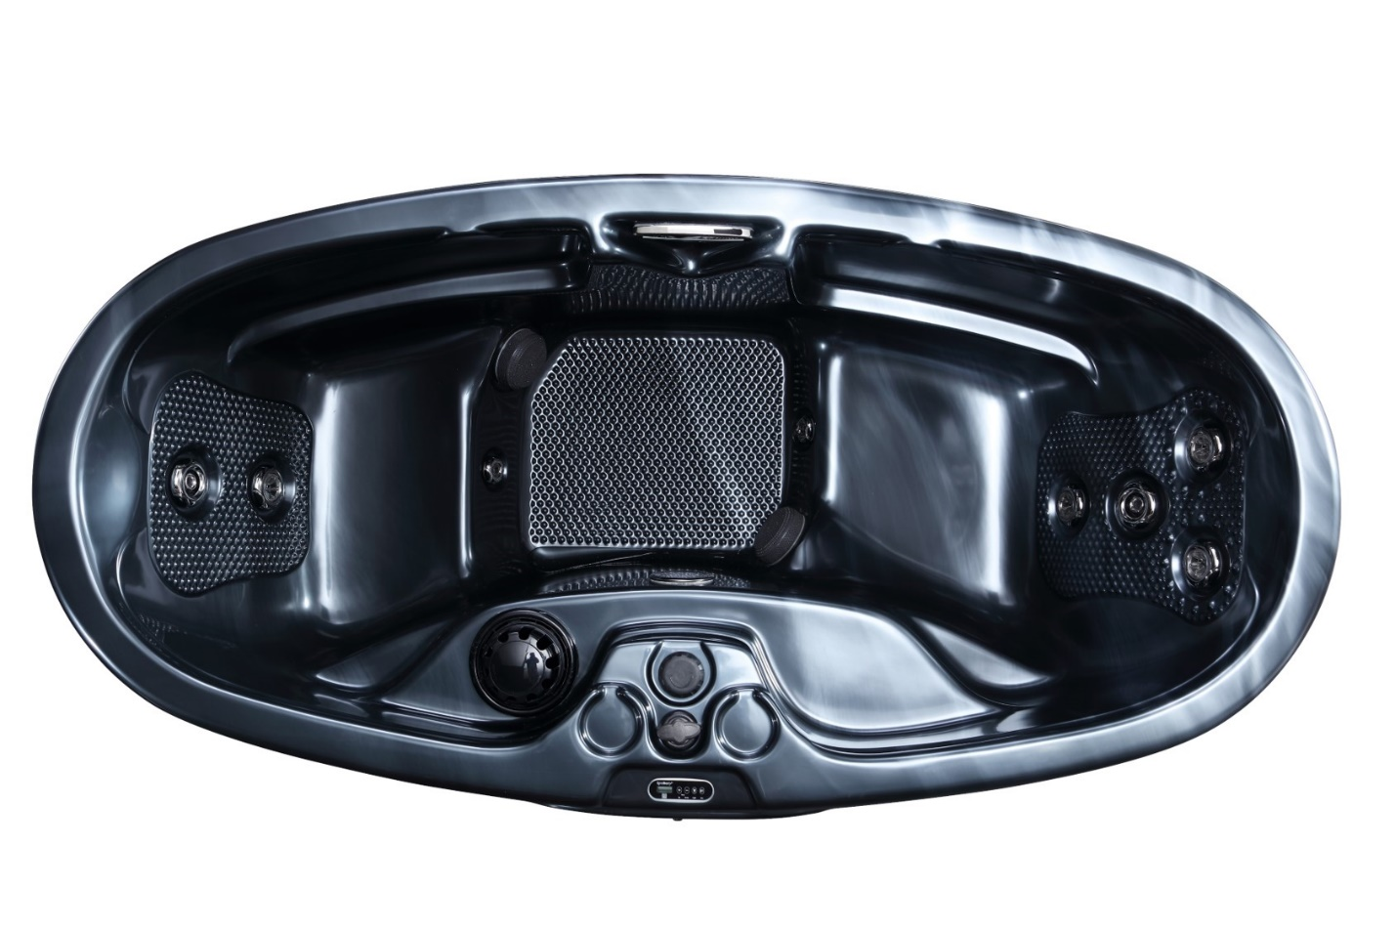

SpaBerry SB3

The SpaBerry SB3 has the same Build Quality of every SpaBerry, Certified PremiumBuilt™ to CommercialGrade™ Standards, designed for people who want to own a well-built hot tub, have a great hot tub experience, with full body massage that fits into their budget.

We’ve incorporated 1,500 BerrySage™ Massage Nodules strategically placed in the footwell to take care of your aching feet after a long day and in the ergonomically designed seat backs to destress the tension from your lower back to the base of your neck.

Powered by SpaBerry’s BerryFlo™ Plumbing and Pump systems, your new SB3 puts out 100 Gallons of water per minute through 8 strategically placed Therapy Jets to massage your aching muscles and filter 100% of your spa water every 75 seconds.

We haven’t cut any corners on the SB3 as it comes complete with…

**BerryTough™ Skeletal Framework** 100% Stainless Steel sub-structure - Built to last a lifetime™

**BerryFlo™ Plumbing** Increased Water Flow for Better Filtration – Quieter Operation – Increased Performance

**BerryFlo™ Pumps** Upgraded pump systems to provide 25% more water flow for improved hydro-therapy massage and improved water filtration

**BerryTuff™** Sealed Undercarriage – For Thicker undercarriage for a longer lasting base – Improved Environmental Intrusion Protection – Increased Structural Reinforcement – Engineered to Last

**BerryVac™** Custom Shell Forming Procedures – More Uniform Shell Thickness for SpaBerry Shell Uniformity – Increased Product Longevity – Improved Shell Performance Characteristics

**UniBody™ Supreme** Construction Advancement – With New Thicker UniBody™ Seamless Construction - Ensuring Shell Durability – Improved Anti-Cracking and Anti-Delamination Characteristics – To Keep the Heat in and the Cold out

**BerryGlide™ Plus** Elevated for Smoother Retractable Equipment Compartment – Making for Stronger, Faster, Easier DIY Serviceability

**BerrySage™** More Aggressive BerrySage™ Nodule Design – For Enhanced Shiatsu Deep Tissue Massage – Anti-Slip Characteristics

**BerryLux™ Shell Construction** with Enhanced UV Inhibitors & Stabilizers – Improved Shell Color Consistency and Longevity – Anti-Stress Composition

**Certified PremiumBuilt™** Engineered/Designed/Tested to withstand -72C – Built to Work/Built to Last in the most Extreme Climates on the Globe

**Commercial LED Lighting Package** CommercialGrade™ LED lit Jets (Large) for greater illumination, safety and mood enhancement, Larger Master LED Light in the Footwell of your SpaBerry

**BerryFlo™ Valve** – Ergonomically placed, Variable Speed Master Valve to adjust the Water Volume of all BerryJetz™ at the same time to customize your massage from Gentle to Extreme

**BerryBleed™ Air Purge Fitting** – Purges all the air out of the plumbing during fill up minimizing the possibility of air locks for quicker and easier start ups

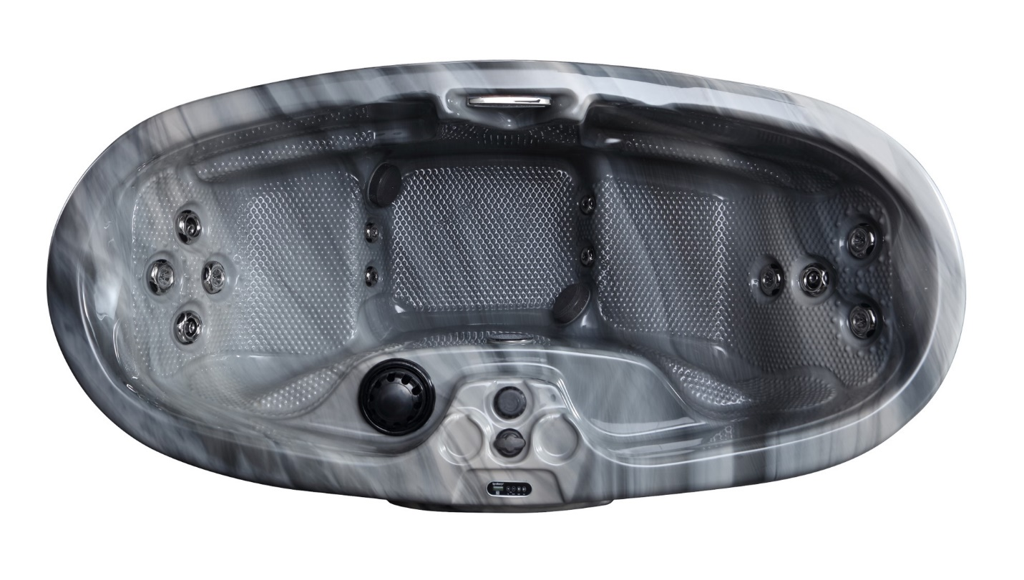SpaBerry SB4

The SpaBerry SB4 is the couple’s tub…designed active adults that love to share their hot tub experience. The SB4 not only has the same Build Quality of every SpaBerry…it’s both Certified PremiumBuilt™ and built to CommercialGrade™ Standards! Designed for people who want to own a well-built hot tub, have a great hot tub experience, and are looking for a powerful level of massage for both bathers.

We’ve incorporated 4,000 BerrySage™ Massage Nodules strategically placed in the footwell to take care of your aching feet after a long day and in the ergonomically designed seat backs to destress the tension from your lower back to the base of your neck as well as the seats and armrests for a complete Shiatsu experience coupled with great Hydrotherapy.

Powered by SpaBerry’s BerryFlo™ Plumbing and Pump systems, your new SB4 puts out an impressive 125 Gallons of water per minute through 12 strategically placed Therapy Jets to massage your aching muscles and filter 100% of your spa water every 60 seconds.

We haven’t cut any corners on the SB3 as it comes complete with…

**BerryTough™ Skeletal Framework** 100% Stainless Steel sub-structure - Built to last a lifetime™

**BerryFlo™ Plumbing** Increased Water Flow for Better Filtration – Quieter Operation – Increased Performance

**BerryFlo™ Pumps** Upgraded pump systems to provide 25% more water flow for improved hydro-therapy massage and improved water filtration

**BerryTuff™** Sealed Undercarriage – For Thicker undercarriage for a longer lasting base – Improved Environmental Intrusion Protection – Increased Structural Reinforcement – Engineered to Last

**BerryVac™** Custom Shell Forming Procedures – More Uniform Shell Thickness for SpaBerry Shell Uniformity – Increased Product Longevity – Improved Shell Performance Characteristics

**UniBody™ Supreme** Construction Advancement – With New Thicker UniBody™ Seamless Construction - Ensuring Shell Durability – Improved Anti-Cracking and Anti-Delamination Characteristics – To Keep the Heat in and the Cold out

**BerryGlide™ Plus** Elevated for Smoother Retractable Equipment Compartment – Making for Stronger, Faster, Easier DIY Serviceability

**BerrySage™** More Aggressive BerrySage™ Nodule Design – For Enhanced Shiatsu Deep Tissue Massage – Anti-Slip Characteristics

**BerryLux™ Shell Construction** with Enhanced UV Inhibitors & Stabilizers – Improved Shell Color Consistency and Longevity – Anti-Stress Composition

**Certified PremiumBuilt™** Engineered/Designed/Tested to withstand -72C – Built to Work/Built to Last in the most Extreme Climates on the Globe

**Commercial LED Lighting Package** CommercialGrade™ LED lit Jets (Large) for greater illumination, safety and mood enhancement, Larger Master LED Light in the Footwell of your SpaBerry

**BerryFlo™ Valve** – Ergonomically placed, Variable Speed Master Valve to adjust the Water Volume of all BerryJetz™ at the same time to customize your massage from Gentle to Extreme

**BerryBleed™ Air Purge Fitting** – Purges all the air out of the plumbing during fill up minimizing the possibility of air locks for quicker and easier start ups

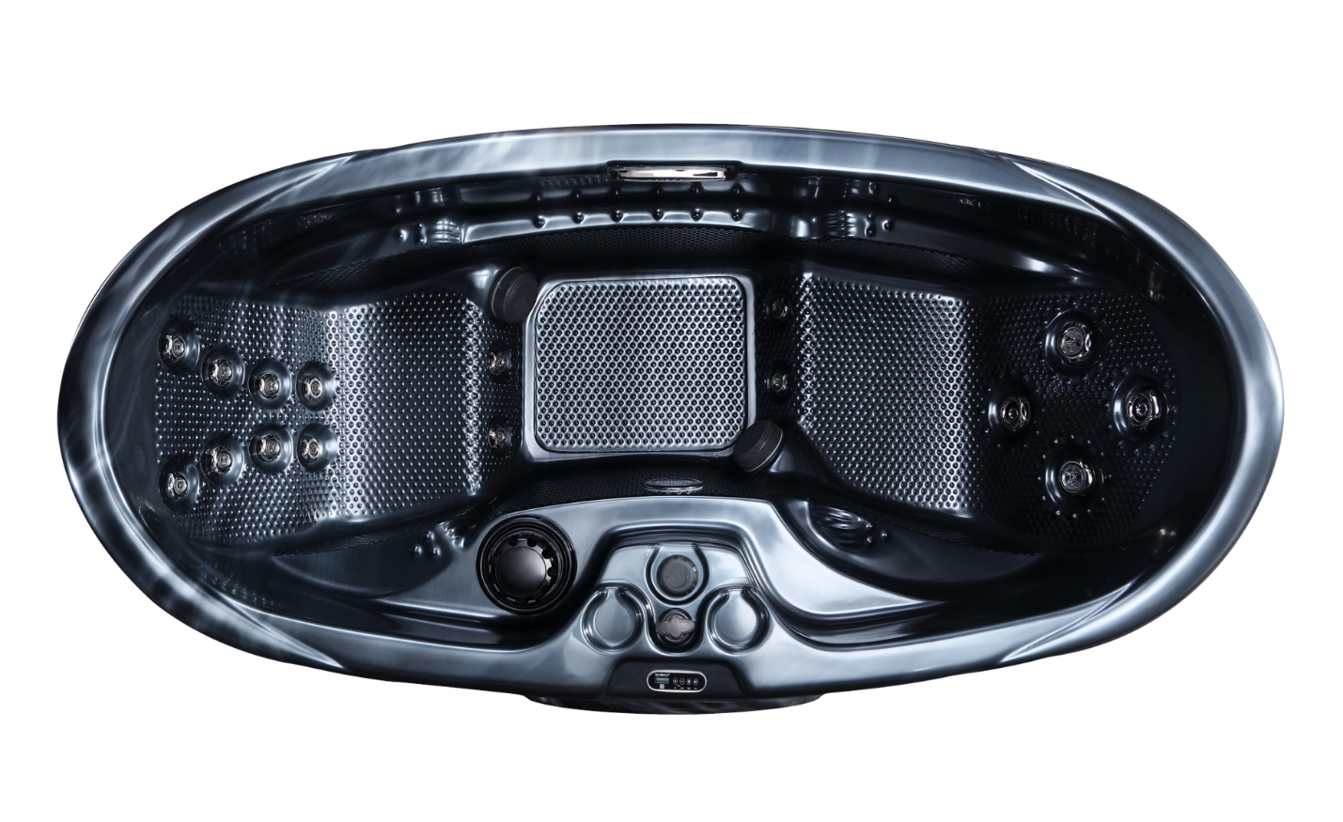SpaBerry SB5

The SpaBerry SB5 is the #1 Selling 2-Person spa in the line-up…sculpted wider on the inside with Biometrically designed seating for large people looking for the ultimate in comfort. The SB5’s unique SkullBerry™ headrests incorporated into the design of the mold supports the bathers head taking the stress off their neck after a long, hard day at the computer.

The SB5 was the 1st SpaBerry to attain the dual status of being both Certified PremiumBuilt™ and built to CommercialGrade™ Standards! Designed for people who want to own the best-built 2-person hot tub with phenomenal looks and unsurpassed performance!

The SB5 is clearly the next level up when it comes to massage therapy with 10,000 BerrySage™ Massage Nodules strategically placed in the footwell to take care of your aching feet after a long day and in the ergonomically designed seat backs to destress the tension from your lower back to the base of your neck as well as the seats and armrests for a complete Shiatsu experience coupled with great Hydrotherapy. Basically…wherever your body touches the shell you experience BerrySage™.

Powered by SpaBerry’s BerryFlo™ Plumbing and Pump systems, your new SB5 puts out an astounding 150 Gallons of water per minute through 16 strategically placed Therapy Jets to massage your aching muscles and filter 100% of your spa water every 50 seconds.

Every SB5 is built without compromise and incorporates…

**BerryTough™ Skeletal Framework** 100% Stainless Steel sub-structure - Built to last a lifetime™

**BerryFlo™ Plumbing** Increased Water Flow for Better Filtration – Quieter Operation – Increased Performance

**BerryFlo™ Pumps** Upgraded pump systems to provide 25% more water flow for improved hydro-therapy massage and improved water filtration

**BerryTuff™** Sealed Undercarriage – For Thicker undercarriage for a longer lasting base – Improved Environmental Intrusion Protection – Increased Structural Reinforcement – Engineered to Last

**BerryVac™** Custom Shell Forming Procedures – More Uniform Shell Thickness for SpaBerry Shell Uniformity – Increased Product Longevity – Improved Shell Performance Characteristics

**UniBody™ Supreme** Construction Advancement – With New Thicker UniBody™ Seamless Construction - Ensuring Shell Durability – Improved Anti-Cracking and Anti-Delamination Characteristics – To Keep the Heat in and the Cold out

**BerryGlide™ Plus** Elevated for Smoother Retractable Equipment Compartment – Making for Stronger, Faster, Easier DIY Serviceability

**BerrySage™** More Aggressive BerrySage™ Nodule Design – For Enhanced Shiatsu Deep Tissue Massage – Anti-Slip Characteristics

**BerryLux™ Shell Construction** with Enhanced UV Inhibitors & Stabilizers – Improved Shell Color Consistency and Longevity – Anti-Stress Composition

**Certified PremiumBuilt™** Engineered/Designed/Tested to withstand -72C – Built to Work/Built to Last in the most Extreme Climates on the Globe

**Commercial LED Lighting Package** CommercialGrade™ LED lit Jets (Large), step inserts (SB5/6) for greater illumination, safety and mood enhancement, Larger Master LED Light in the Footwell of your SpaBerry

**BerryFlo™ Valve** – Ergonomically placed, Variable Speed Master Valve to adjust the Water Volume of all BerryJetz™ at the same time to customize your massage from Gentle to Extreme

**BerryBleed™ Air Purge Fitting** – Purges all the air out of the plumbing during fill up minimizing the possibility of air locks for quicker and easier start ups

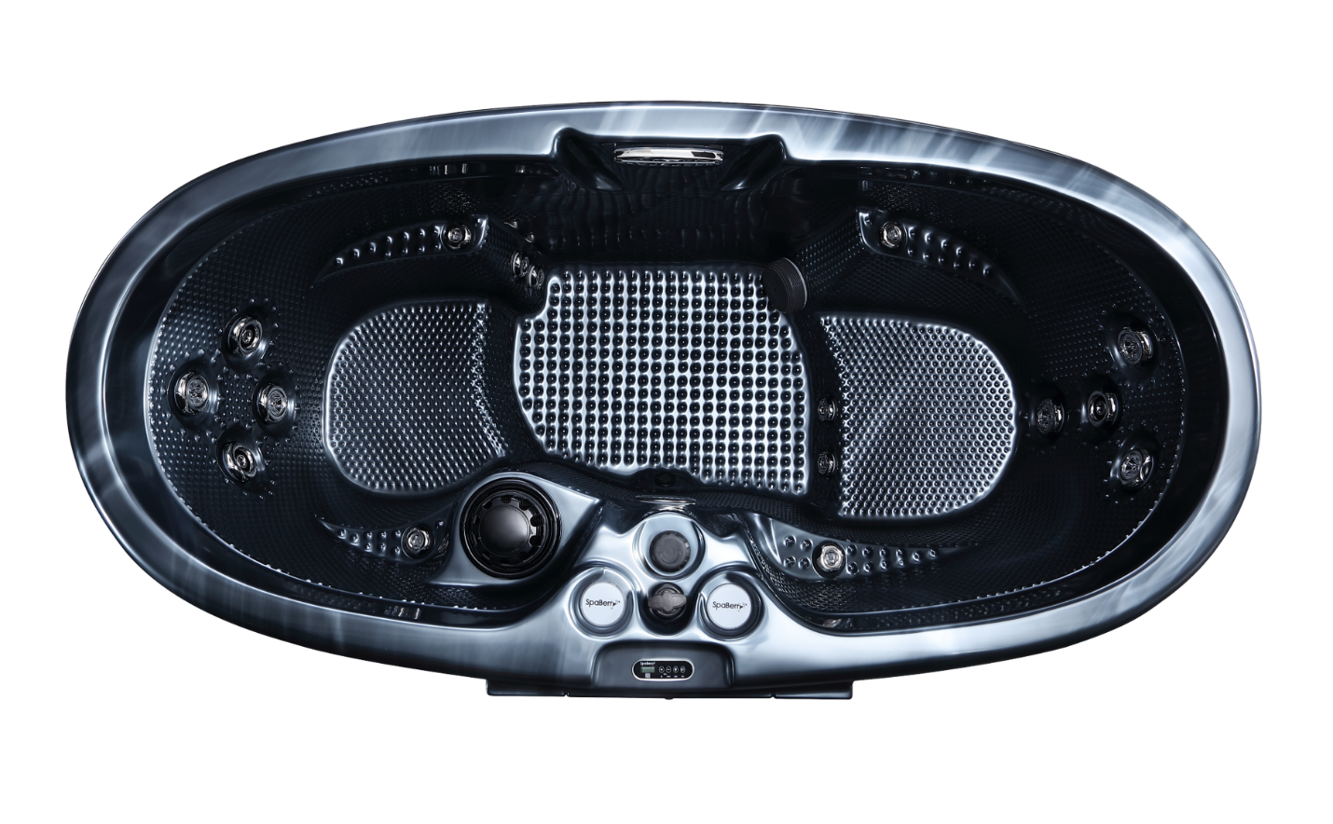

SpaBerry SB6

The SpaBerry SB6 is the Pinnacle of the SpaBerry line-up…featuring 2 full body depth Biometrically designed seats for full body immersion. The SB6 features stunning design architecture with its unique subway tile etched exterior, Black Glass LED LIT Equipment door accented by dual inset LED LIT Steps incorporated into the exterior.

The SB6 has the dual status of being both Certified PremiumBuilt™ and built to CommercialGrade™ Standards! Designed for people who want to have a unique design, like a piece of art to accentuate their environment with phenomenal looks and performance!

The SB6 is not only an architectural achievement in hot tub design it features the ultimate in massage therapy with 12,000 BerrySage™ Massage Nodules strategically placed in the footwell to take care of your aching feet after a long day and in the ergonomically designed seat backs to destress the tension from your lower back to the base of your neck as well as the seats and armrests for a complete Shiatsu experience coupled with great Hydrotherapy. Basically…wherever your body touches the shell you experience BerrySage™.

Powered by SpaBerry’s BerryFlo™ Plumbing and Pump systems, your new SB6 puts out an astounding 150 Gallons of water per minute through 16 strategically placed Therapy Jets to massage your aching muscles and filter 100% of your spa water every 50 seconds.

Every SB6 is built with incomparable design and without compromise incorporating…

**BerryTough™ Skeletal Framework** 100% Stainless Steel sub-structure - Built to last a lifetime™

**BerryFlo™ Plumbing** Increased Water Flow for Better Filtration – Quieter Operation – Increased Performance

**BerryFlo™ Pumps** Upgraded pump systems to provide 25% more water flow for improved hydro-therapy massage and improved water filtration

**BerryTuff™** Sealed Undercarriage – For Thicker undercarriage for a longer lasting base – Improved Environmental Intrusion Protection – Increased Structural Reinforcement – Engineered to Last

**BerryVac™** Custom Shell Forming Procedures – More Uniform Shell Thickness for SpaBerry Shell Uniformity – Increased Product Longevity – Improved Shell Performance Characteristics

**UniBody™ Supreme** Construction Advancement – With New Thicker UniBody™ Seamless Construction - Ensuring Shell Durability – Improved Anti-Cracking and Anti-Delamination Characteristics – To Keep the Heat in and the Cold out

**BerryGlide™ Plus** Elevated for Smoother Retractable Equipment Compartment – Making for Stronger, Faster, Easier DIY Serviceability

**BerrySage™** More Aggressive BerrySage™ Nodule Design – For Enhanced Shiatsu Deep Tissue Massage – Anti-Slip Characteristics

**BerryLux™ Shell Construction** with Enhanced UV Inhibitors & Stabilizers – Improved Shell Color Consistency and Longevity – Anti-Stress Composition

**Certified PremiumBuilt™** Engineered/Designed/Tested to withstand -72C – Built to Work/Built to Last in the most Extreme Climates on the Globe

**Commercial LED Lighting Package** CommercialGrade™ LED lit Jets (Large), step inserts (SB5/6) for greater illumination, safety and mood enhancement, Larger Master LED Light in the Footwell of your SpaBerry

**BerryFlo™ Valve** – Ergonomically placed, Variable Speed Master Valve to adjust the Water Volume of all BerryJetz™ at the same time to customize your massage from Gentle to Extreme

**BerryBleed™ Air Purge Fitting** – Purges all the air out of the plumbing during fill up minimizing the possibility of air locks for quicker and easier start ups